**KNN Algorithm**

**Key points to remember:**

1. Supervised ML algorithm
2. Used for classification and regression
3. Neighbors logic
4. Works upon similarity distance metric

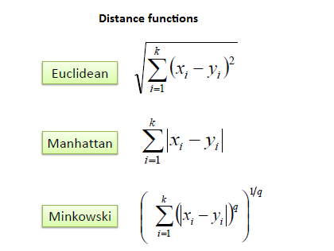

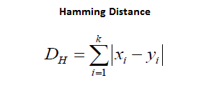

1. Suits noisy data, works well upon lesser data

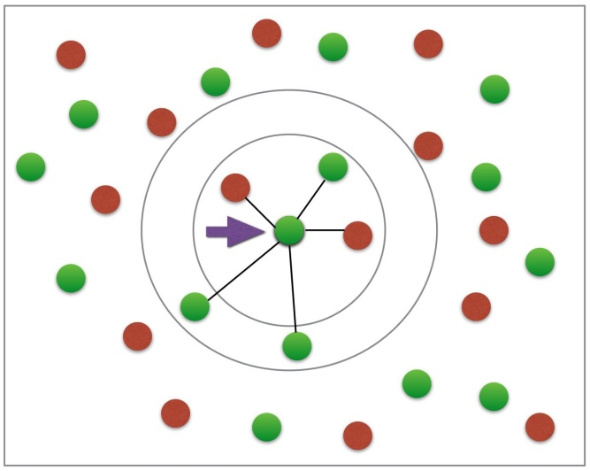

1. Value of K

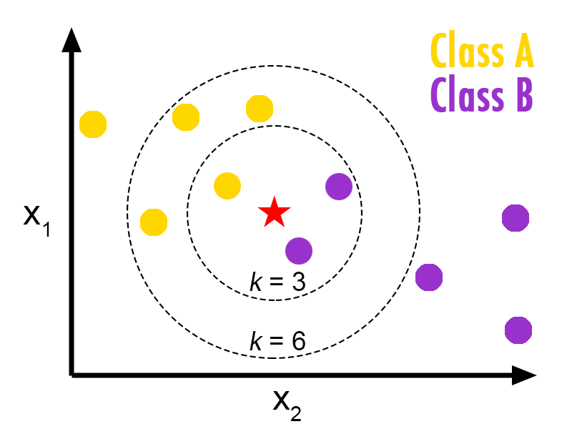 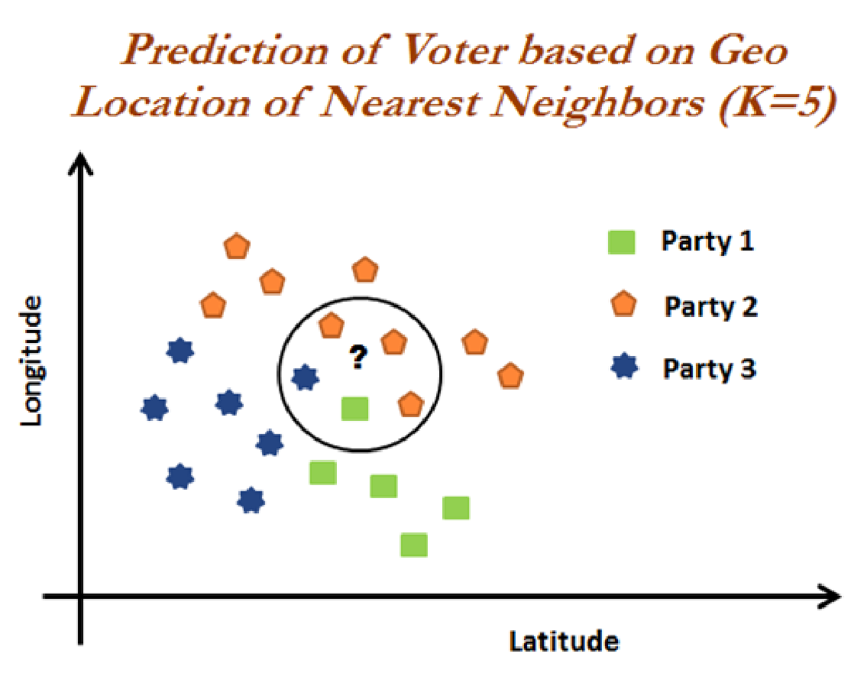

1. How to choose value of K: Sqrt approach, trial and error approach, maintain odd even values for class and k
2. How is the predicted value chosen?

Classification-mode of the neighbours classes

Regression-mean of the neighbours Y value

1. Lazy algorithm

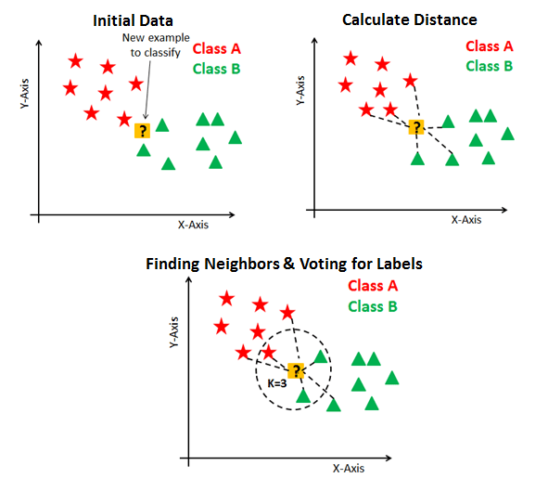

**KNN Algorithm Steps:**

1. Load the data-Train the model

2. Initialize K to your chosen number of neighbors

3. For each observation in the train data:

3.1 Calculate the distance between the query(test) observation and the current observation from the train data.

3.2 Add the distance and the index of the observation to an ordered collection(memory table)

4. Sort the ordered collection of distances and indices from smallest to largest (in ascending order) by the distances

5. Pick the first K entries from the sorted collection

6. Get the labels of the selected K entries

7. If regression, return the mean of the K labels

8. If classification, return the mode of the K labels

